Unit 6: CERT Organization

In this unit you will learn about:
- CERT Organization: How to organize and deploy CERT resources according to CERT organizational principles.
- Rescuer Safety: How to protect your own safety and your buddy’s during search and rescue.
- Documentation: Strategies for documenting situation and resource status.
- Team Organization: A tabletop exercise to apply your knowledge of team organization.

[This page intentionally left blank]

Introduction and Unit Overview

Unit Objectives
At the end of this unit, you should be able to:
- Describe the CERT structure.
- Identify how CERTs interrelate with the Incident Command System (ICS).
- Explain documentation requirements.
Unit Topics
This unit will provide you with a thorough understanding of CERT organization and policy.
- CERT Organization
- CERT Mobilization
- Documentation
Effective CERT operations, like all aspects of emergency response, rely on effective communication.

CERT Organization

Principles of Onscene Management
Onscene management in a disaster situation has three primary goals:
- Maintain the safety of disaster workers. The CERT Incident Commander/Team Leader (IC/TL) must continually prioritize response activities based on the team’s capability and training and the principle that rescuer safety is the number one concern. CERT functional leadership assigns activities and accounts for team members. CERT members work in the buddy system and respond based on their sizeup of the situations that they encounter.
- Provide clear leadership and organizational structure by developing a chain of command and roles that are known by all team members. Each CERT member has only one person that he or she takes direction from and responds to.
- Improve the effectiveness of rescue efforts. Disaster information is collected and responses are prioritized based on rescuer safety and doing the greatest good for the greatest number according to the team’s capabilities and training.
CERT organization is based on the Incident Command System (ICS), which is a proven management system used by emergency responders.
CERT Onscene Management
The specific CERT organizational structure and protocols provide:
- A well-defined management structure (e.g., leadership, functional areas, reporting chain, working in teams)
- A manageable span of control that provides for a desirable rescuer-to-supervisor ratio of between three and seven rescuers per supervisor
- Common terminology that contributes to effective communication and shared understanding
- Effective communication among team members and with professional responders, including the use of radios

CERT Organization (Continued)
- Consolidated action plans that coordinate strategic goals, tactical objectives, and support activities
- Comprehensive resource management that facilitates application of available resources to the incident in a timely manner
- Accountability
Objectives for CERT Onscene Management
In a disaster situation, the CERT:
- Identifies the scope of the incident (What is the problem?)
- Determines an overall strategy (What can we do, and how will we do it?)
- Deploys teams and resources (Who is going to do what?)
- Documents actions and results
The Need for Flexibility
Disasters create a dynamic, ever-changing environment. The CERT organizational framework is flexible so that it can expand or contract depending on the ongoing assessment priorities determined by the CERT Incident Commander/Team Leader (IC/TL), and people and resources available. This expansion and contraction helps ensure:
- Rescuer safety
- Doing the greatest good for the greatest number
- A manageable span of control
- Accountability of CERT members

CERT Organization (Continued)
Incident Command System
The Incident Command System (ICS) is the system used by emergency response agencies to manage emergency operations. When CERTs activate, they become part of that system.
Basic ICS structure for CERT is established by the person who arrives first on the scene. This person becomes the Incident Commander/Team Leader (IC/TL). Initially, the IC/TL may handle all of the command positions of ICS but, as the incident evolves, he or she may assign personnel as needed to the four ICS Command Functions:
- Operations Section Chief
- Logistics Section Chief
- Planning Section Chief
- Finance/Administration Section Chief
Through an effective ICS, all CERT members report through a chain of command to the IC/TL. The IC/TL reports to the first fire or law enforcement official at their location and takes direction from that person until otherwise directed or until the CERT is relieved.

ICS Command Function Organization Chart

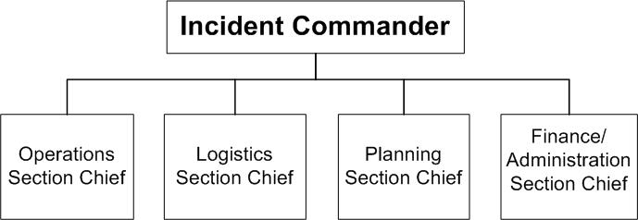

CERT Organization (Continued)
Although there are a number of detailed responsibilities under each ICS function, the system itself is straightforward. CERTs will typically require the Operations, Planning, and Logistics functions. The CERT Incident Commander/Team Leader (IC/TL) is responsible for handling or delegating each function.
As the incident expands, CERT members are assigned or re-assigned to each section to handle specific aspects of the response while maintaining an effective span of control.

CERT Incident Commander/Team Leader

Provides overall leadership for incident response

Ensures incident safety

Establishes incident objectives

Is responsible for all functions until delegated

Delegates authority to others

Provides information to internal and external parties

Establishes and maintains liaison with other responders (e.g., fire, law enforcement, public works, other CERTs)
- Takes direction from agency official

Operations Section

Directs and coordinates all incident tactical operations

Is typically one of the first functions to be assigned

CERT Organization (Continued)
Planning Section
- Tracks resource status (e. g., number of CERT members who have “reported for duty”)
- Tracks situation status
- Prepares the Team’s action plan
- Develops alternative strategies

Provides documentation services
Logistics Section
- Provides communications
- Provides food and medical support to Team members
- Manages supplies and facilities
Finance and Administration Section
- Contract negotiation and monitoring
- Timekeeping
- Cost analysis
- Compensation for injury or damage to property
Finance and Administration is a function in the formal Incident Command System; however, CERTs will have very limited need, if any, for this function.

CERT Organization (Continued)

CERT Operations
Based on the principles of ICS, CERTs follow these protocols:
- Each CERT must establish a command structure.
- The CERT Incident Commander/Team Leader (IC/TL) directs team activities. During activation for a disaster, the first person at a predesignated staging area assumes this responsibility. The initial IC/TL may hand off this role to a predesignated leader when that person arrives.
- The location established by the CERT IC/TL as the central point for command and control of the incident is called the Command Post for the CERT. The IC/TL stays in the Command Post. If the IC/TL has to leave, the responsibility of IC/TL must be delegated to someone in the Command Post.
Using the ICS structure, CERT members are assigned to assist with a range of functions:
- Logistics — managing resources, services, and supplies
- Planning/Intelligence — collecting and displaying information; collecting and compiling documentation
- Operations — conducting fire suppression, medical operations, search and rescue
In all situations, each unit assigned must have an identified leader to supervise tasks being performed, to account for team members, and to report information to his or her designated leader.
In all situations, a manageable span of control is three to seven team members reporting to their designated leader.
CERT personnel assigned to Operations should always be assigned to teams consisting of at least three to four persons:
- One person will serve as runner and communicate with the Command Post.
- Two people will “buddy up” to respond to the immediate needs.
- Search and rescue teams must include at least four people, with a safety person remaining outside the area to be searched and at least two people to conduct the search.

Expanded CERT Operations Structure

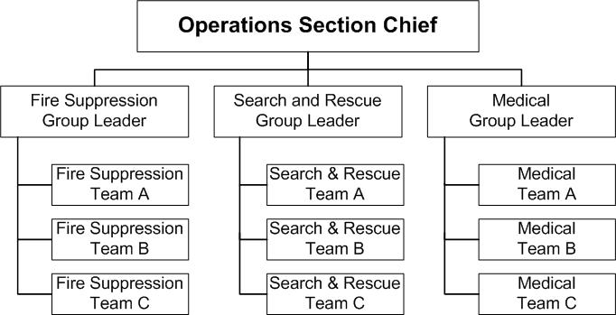

CERT operations section structure, showing the Operations Section Chief at the top and the three Group Leaders underneath

CERT Organization (Continued)
Dealing with the Media
CERT members should refer any media inquiries to the CERT IC/TL. The IC/TL should then refer the media inquiries to the Public Information Officer of the CERTs’ sponsoring organization.
If the Public Information Officer of the sponsoring organization refers media to the CERT IC/TL or otherwise authorizes them to speak with the media, the IC/TL should:
- Refrain from addressing the media until doing so will no longer inhibit or delay the team’s ability to do the greatest good for the greatest number in the shortest amount of time
- Establish an area for briefing the media if necessary
- Be careful about the information he or she releases, making sure it is both accurate and approved for release, while also keeping in mind victims’ right to privacy
- Not feel compelled to answer every question asked
NIMS Compliance
The Incident Command System is part of the National Incident Management System (NIMS). NIMS provides a consistent, comprehensive approach to incident management. It applies at all jurisdictional levels and across all emergency management functions and types of incidents.
NIMS was established so that first responders, including CERT members, from different jurisdictions and disciplines can work together better to respond to disasters and emergencies.
- To meet NIMS standards, CERT members must complete both the IS-100.a (Introduction to Incident Command System) and IS-700.b (Introduction to National Incident Management System [NIMS]) courses.
- Both independent study courses are available online from FEMA at http://training.fema.gov/IS/NIMS.asp.

CERT Mobilization
The following steps describe how CERTs mobilize when an incident occurs. Immediately following the incident, CERT members take care of themselves, their families, their homes, and their neighbors.
- If the standard operating procedure (SOP) calls for self-activation, CERT members proceed to the predesignated staging area with their disaster supplies. Along the way, they make damage assessments that would be helpful for the CERT IC/TL’s decision-making.
- The first CERT member at the staging area becomes the initial IC/TL for the response. As other CERT members arrive, the CERT IC/TL may pass leadership to someone else. The CERT IC/TL establishes operations to ensure effective communication, to maintain span of control, to maintain accountability, and to do the greatest good for the greatest number without placing CERT members in harm’s way.
- One of the CERT IC/TL’s first decisions will be to locate the team’s Command Post. The staging area may become the Command Post; however, if another location would be safer or otherwise better, the Command Post should be set up there.
- As intelligence is collected and assessed, the IC/TL must prioritize actions and work with the Section Chiefs or leaders. The CERT organization is flexible and evolves based on new information.
Following an incident, information — and, therefore, priorities — may be changing rapidly. Communication between the CERT IC/TL and response teams ensures that CERTs do not overextend their resources or supplies.
Rescuer Safety
Effective emergency scene management requires the formulation and communication of strategic goals and tactical objectives to do the most good for the greatest number while maintaining the safety of rescue personnel.

CERT Mobilization (Continued)
Remember that rescuer safety is paramount. The first question to ask is, “Is it safe for the CERT members to attempt the rescue?” The answer to this question is based mainly on the degree of damage:
- If the damage is heavy: No rescue should be attempted. Use tape around the area or mark the area as heavy damage. CERT members do not have any legal authority to stop or restrict someone who wants to enter an area. At best, CERT members can warn others about the danger and inform the CERT IC/TL immediately if it is known that people are in the building.
- If the damage is moderate: Locate, triage (quickly evaluate, and treat Immediates for airway obstruction, bleeding, and shock), and immediately evacuate victims to a safe area while minimizing both the number of rescuers inside the building and the amount of time that they remain inside.
- If the damage is light: Locate, triage, continue sizeup, and document.

CERT Rescue Efforts Based on Degree of Damage
Degree of Damage | Should Rescue Be Attempted?
Heavy | No. Too dangerous to enter. Warn people to stay away. Inform the CERT Incident Commander/Team Leader (IC/TL) immediately if it is known that people are in the building.
Moderate | Yes, but perform only quick and safe removals; limit onsite medical care to checking for breathing, stopping major bleeding, and treating for shock. Minimize the number of rescuers inside the building.
Light | Yes. Locate, triage, continue sizeup, and document.

CERT Tasks Based on Damage Level
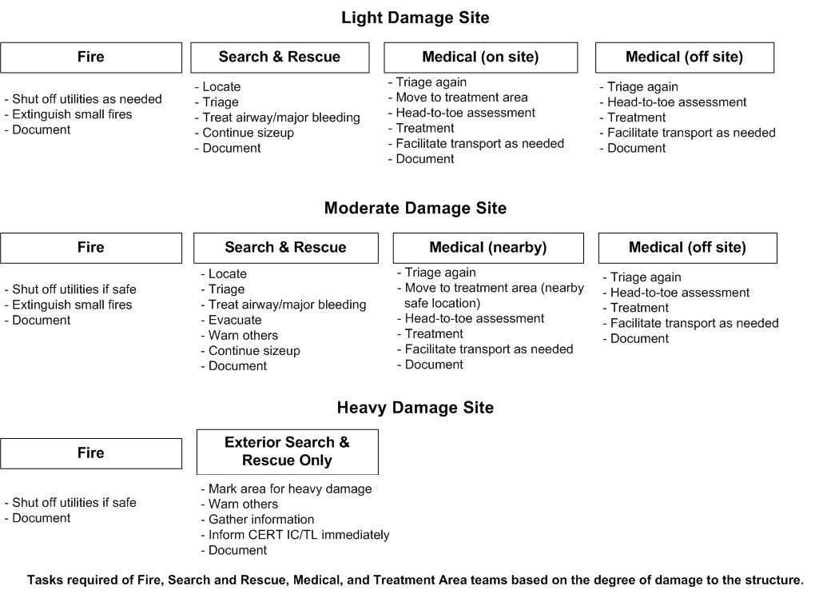

Documentation
It is extremely important to document and communicate information about the disaster situation and resource status.
Efficient flow of information makes it possible for resources to be deployed effectively and for professional emergency services to be applied appropriately.
Documenting serves several purposes:
- The CERT IC/TL will know what is happening throughout the incident.
- The CERT IC/TL will have written information to pass on to the professional responders when they arrive.
- The CERT will be able to show how many volunteer hours it provided to the sponsoring agency or entity.
- Liability exposure will be documented.
- Communication will be improved:
- Between the functional areas
- Between shifts
Under the CERT structure, each level of organization has documentation responsibilities:
- Section Chiefs are responsible for providing the Command Post with ongoing information about damage assessment, group status, and ongoing needs.
- The Command Post is responsible for documenting the situation status, including:
- Incident locations
- Access routes
- Identified hazards
- Support locations

Documentation (Continued)
Support locations include:
- A staging area
- A medical treatment and triage area
- A morgue, if there are fatalities
This information is vital for tracking the overall situation and for the CERT IC/TL to be ready to provide the documentation to the first professional responders on the scene.
Write it down! The most important thing to do is to write down what happened.
The information can be written down on the sample forms provided in this unit or it can be written down on a piece of paper.
Every entity such as a functional team or staging location must have a scribe to record everything. The CERT IC/TL typically designates the scribe and provides some simple instructions.
Documentation Forms
There are eight standard forms that can be used to facilitate documentation and information flow. The forms are functionally consistent with Incident Command System (ICS) forms and are designed to be NIMS compliant.
The CERT forms are:
- Damage Assessment
- Personnel Resources Sign-In
- Incident/Assignment Tracking Log
- Briefing Assignment
- Victim Treatment Area Record
- Communications Log
- Equipment Inventory
- General Message
Remember that scribes can produce useful, high-quality documentation without using the forms as long as they take detailed notes of all activities.

Forms Used for Response Documentation
Form | Purpose
Damage Assessment  [CERT Form #1] | - Completed by CERT members as they travel through the area to the CERT’s staging location, then given to the CERT IC/TL; provides a summary of overall hazards in selected areas, including:  - Fires  - Utility hazards  - Structural damage  - Injuries and casualties  - Available access  - Essential for prioritizing and formulating action plans
Personnel Resources Sign-In  [CERT Form #2] | - Used to sign in CERT members as they arrive at the staging location; provides information about:  - Who is on site  - When they arrived  - When they were assigned  - Their special skills  - Used by staging personnel to track personnel availability
Incident/Assignment Tracking Log  [CERT Form #3] | - Used by the Command Post for keeping abreast of situation status; contains essential information for tracking the overall situation
Briefing Assignment  [CERT Form #4.a-b] | - Used by the Command Post to provide instructions to functional teams; used by teams to log their actions and report new damage assessment information
Victim Treatment Area Record  [CERT Form #5] | - Completed by medical treatment area personnel to record victims entering the treatment area, their condition, and their status
Communications Log  [CERT Form #6 (based on ICS 309)] | - Completed by the radio operator; used to log incoming and outgoing transmissions
Equipment Inventory  [CERT Form #7(based on ICS 303)] | - Used to check out and check in CERT-managed equipment
General Message  [CERT Form #8 (ICS 213)] | - Used for sending messages between command levels and groups; messages should be clear and concise and should focus on such key issues as:  - Assignment completion  - Additional resources required  - Special information  - Status update

Documentation (Continued)
Documentation Flow
Here is how a CERT would use these standard documents within the context of an event. Remind participants that, even if the forms are not used, this should give them an idea of the preferred information that needs to be collected and communicated between groups.
- The Damage Assessment Form is completed by CERT members as they travel through the area to the CERT’s staging location. The form is then given to the CERT IC/TL. The form provides a summary of overall hazards in selected areas. The information is used for prioritizing and formulating activities.
- The CERT IC/TL assembles teams and makes assignments based on the damage assessment information. This person keeps the Incident/ Assignment Tracking Log, which is the most important tool for recording the activities of the functional teams and overall situation status.
- A scribe at the staging location signs in each volunteer using the Personnel Resources Sign-In Form, noting any particular preferred team assignments or skills. This information needs to be passed on to the Command Post.
- The Briefing Assignment Form is shared by the Command Post and the functional team. The CERT IC/TL uses the front side of the form to communicate instructions about an incident such as address, incident type, and team objectives. The scribe of the functional team uses the back side (blank side) of the form to log team actions. The form is returned to the Command Post when the team checks in.
- The Victim Treatment Area Record is used to document each person brought into the treatment area and his or her condition (Immediate, Delayed, or Minor).
- The Communications Log is used to log incoming and outgoing transmissions; it is typically kept by the radio operator.
- The Equipment Inventory is kept in the area or vehicle in which equipment is stored.
- The General Message form is used for sending messages between any command levels and groups. The messages must be clear and concise.

Documentation (Continued)
Documentation Forms
Area maps, site maps, and building plans are also very useful for tracking response activities.
The forms on the following pages will assist in collecting and organizing critical information during CERT operations. However, information needs to be recorded even if the correct form is not available. That is one reason why all members need a small notebook and a pen in their personal CERT kit. Remember, write it down!

Note: For many of the forms, one section is filled out as an example.

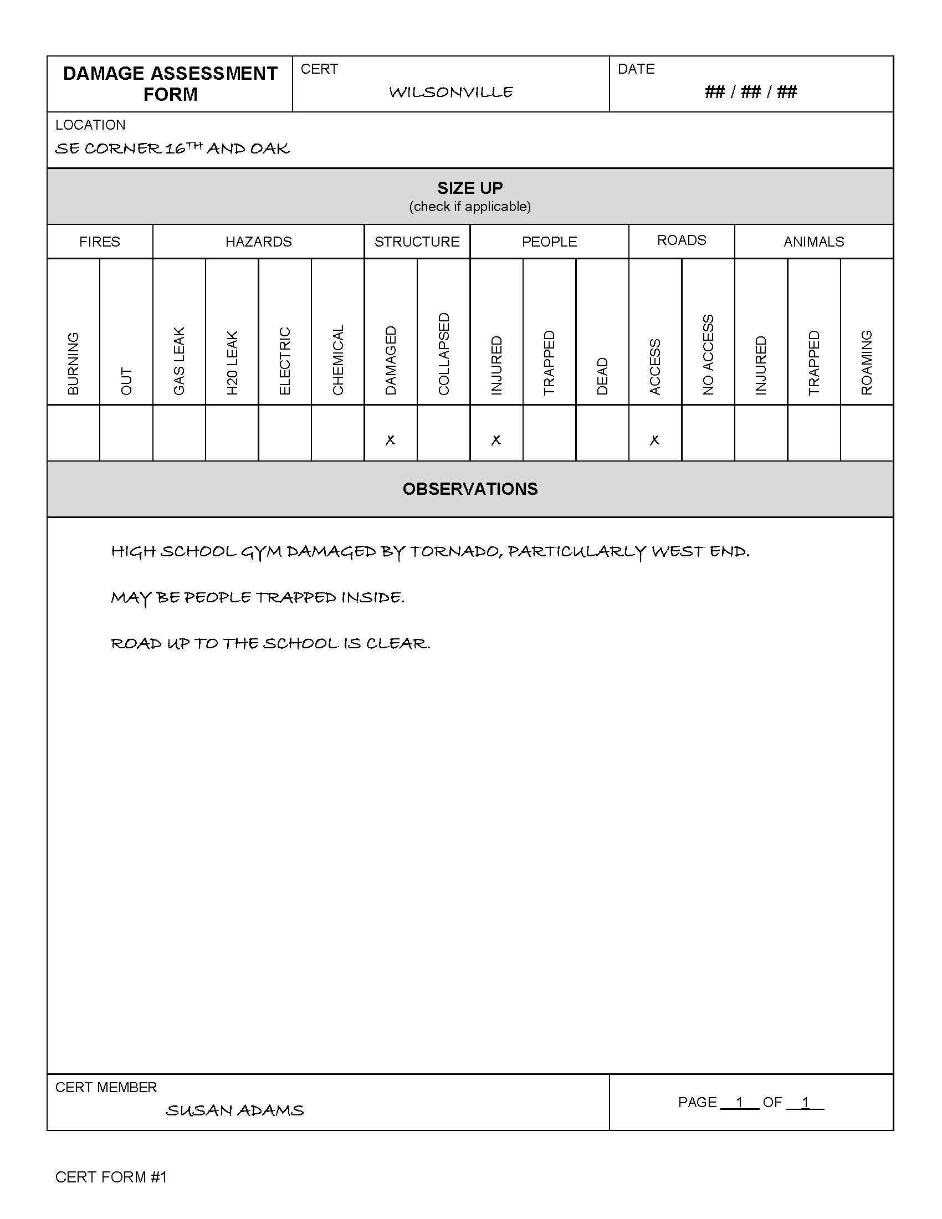
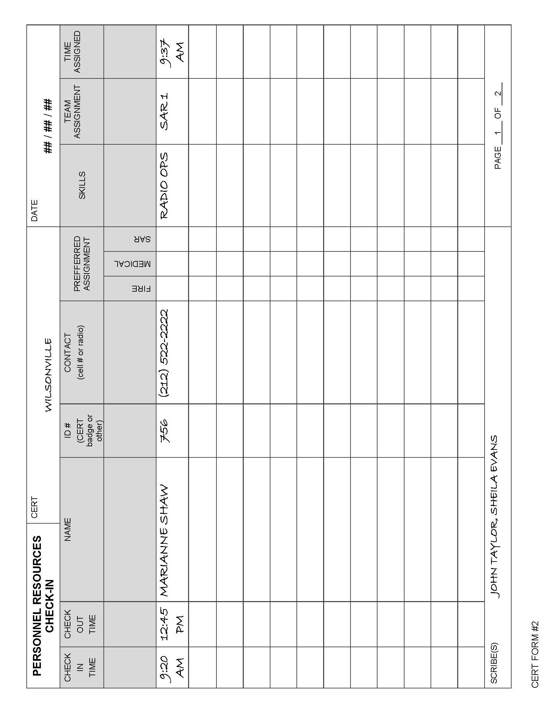
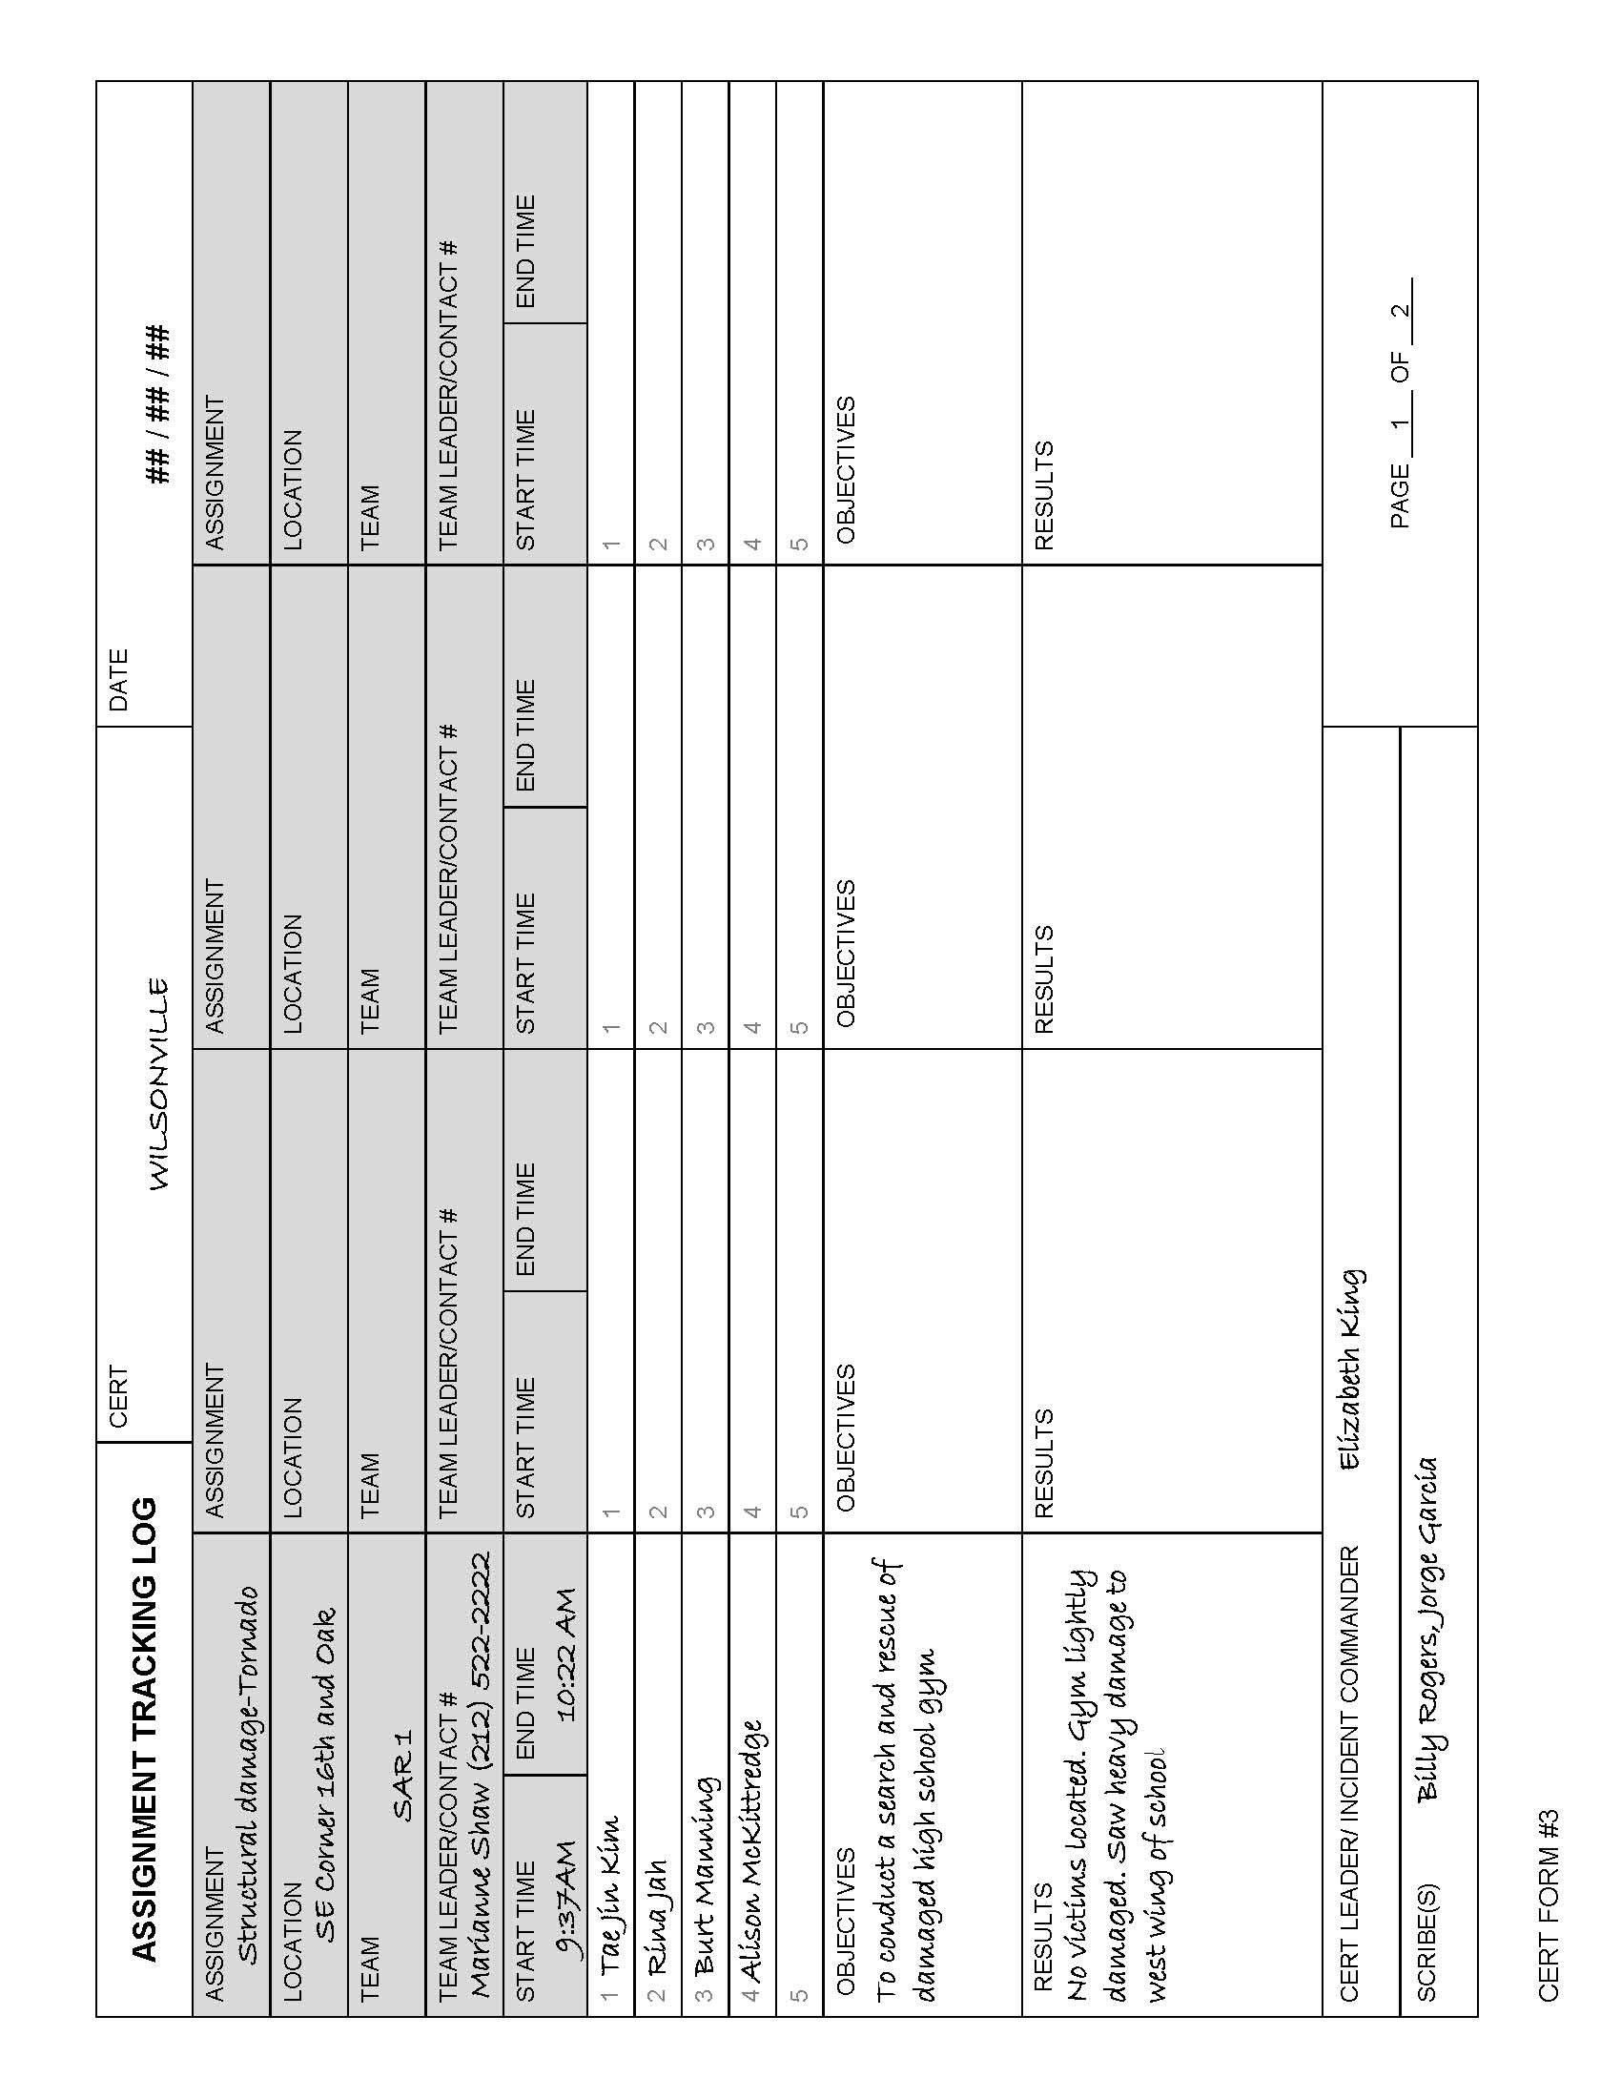
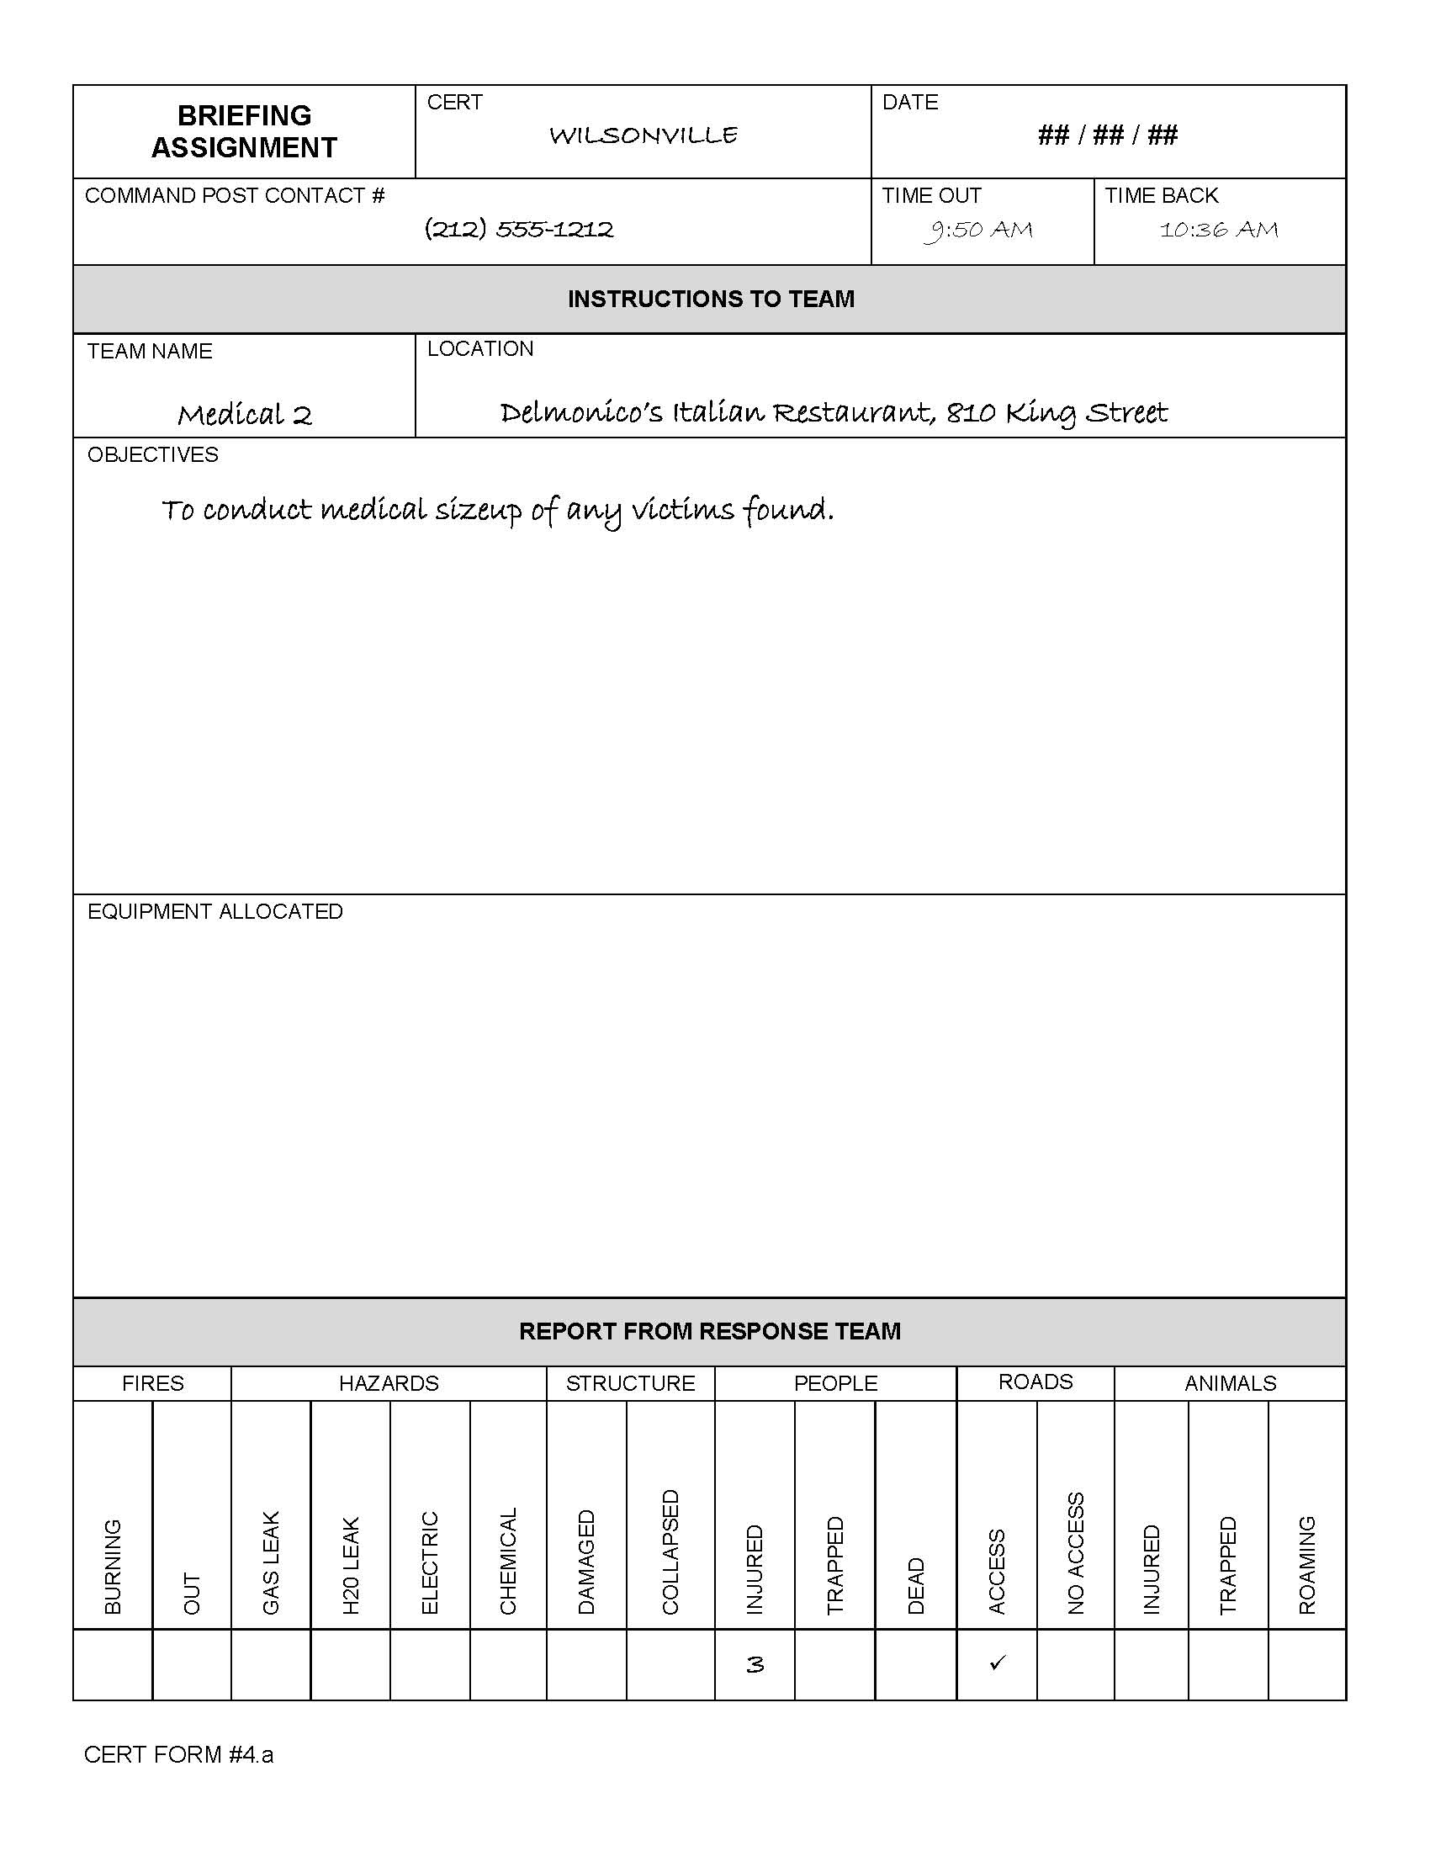
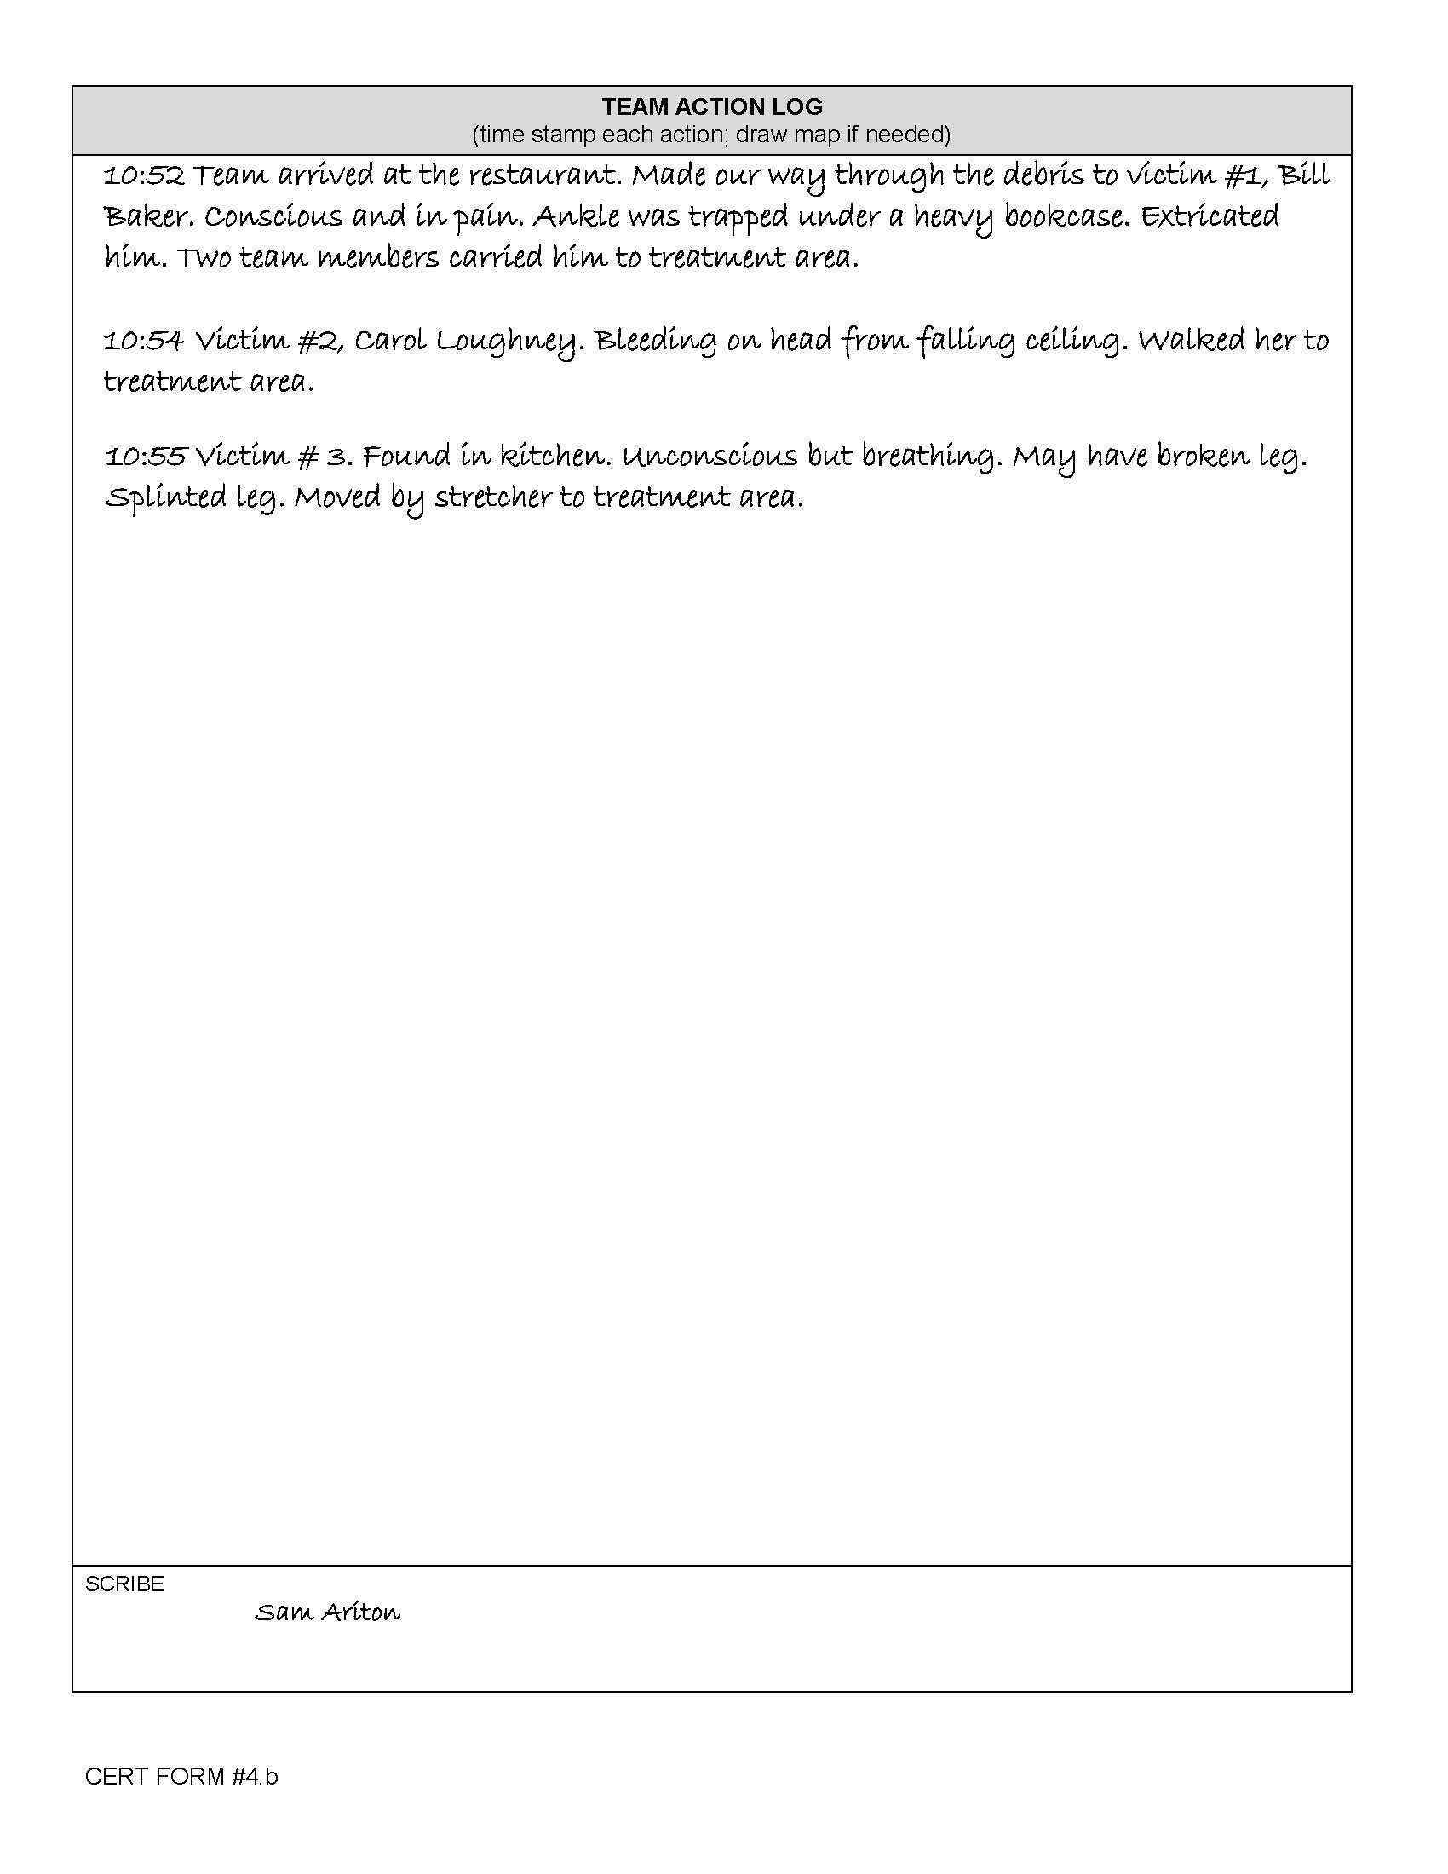
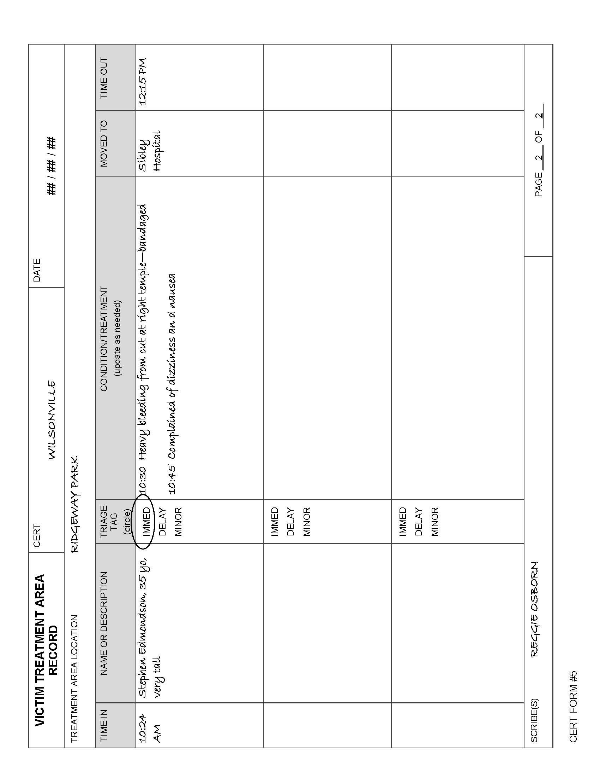
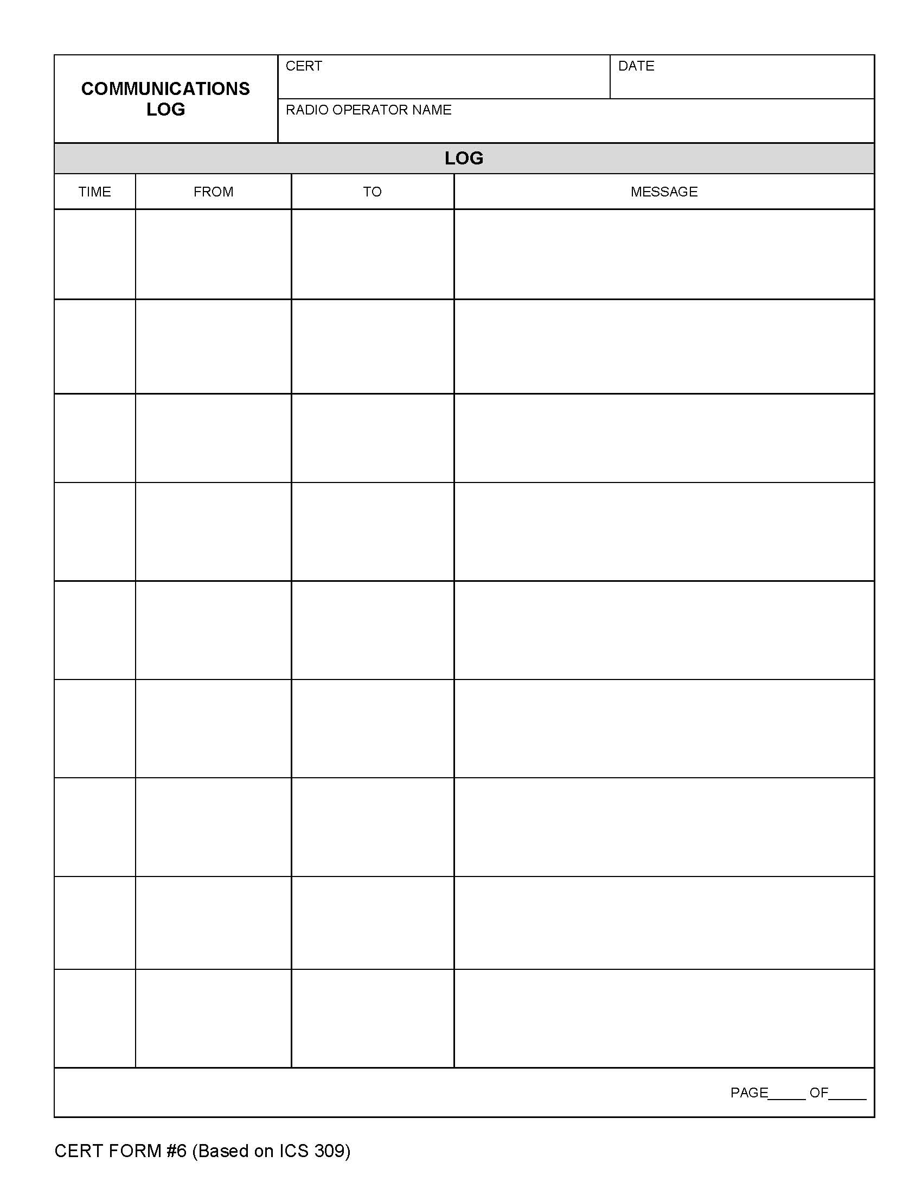
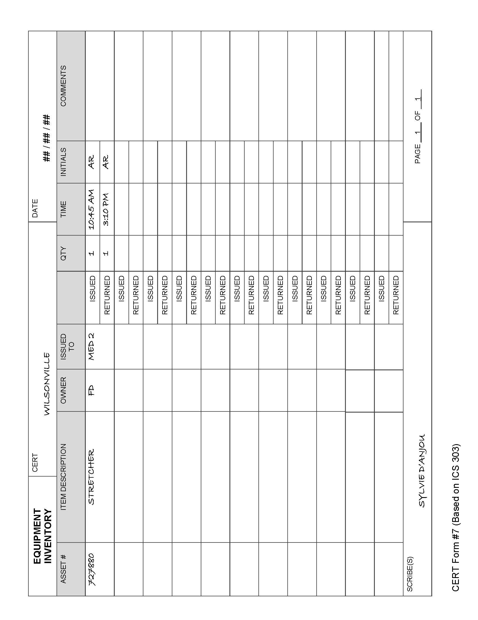
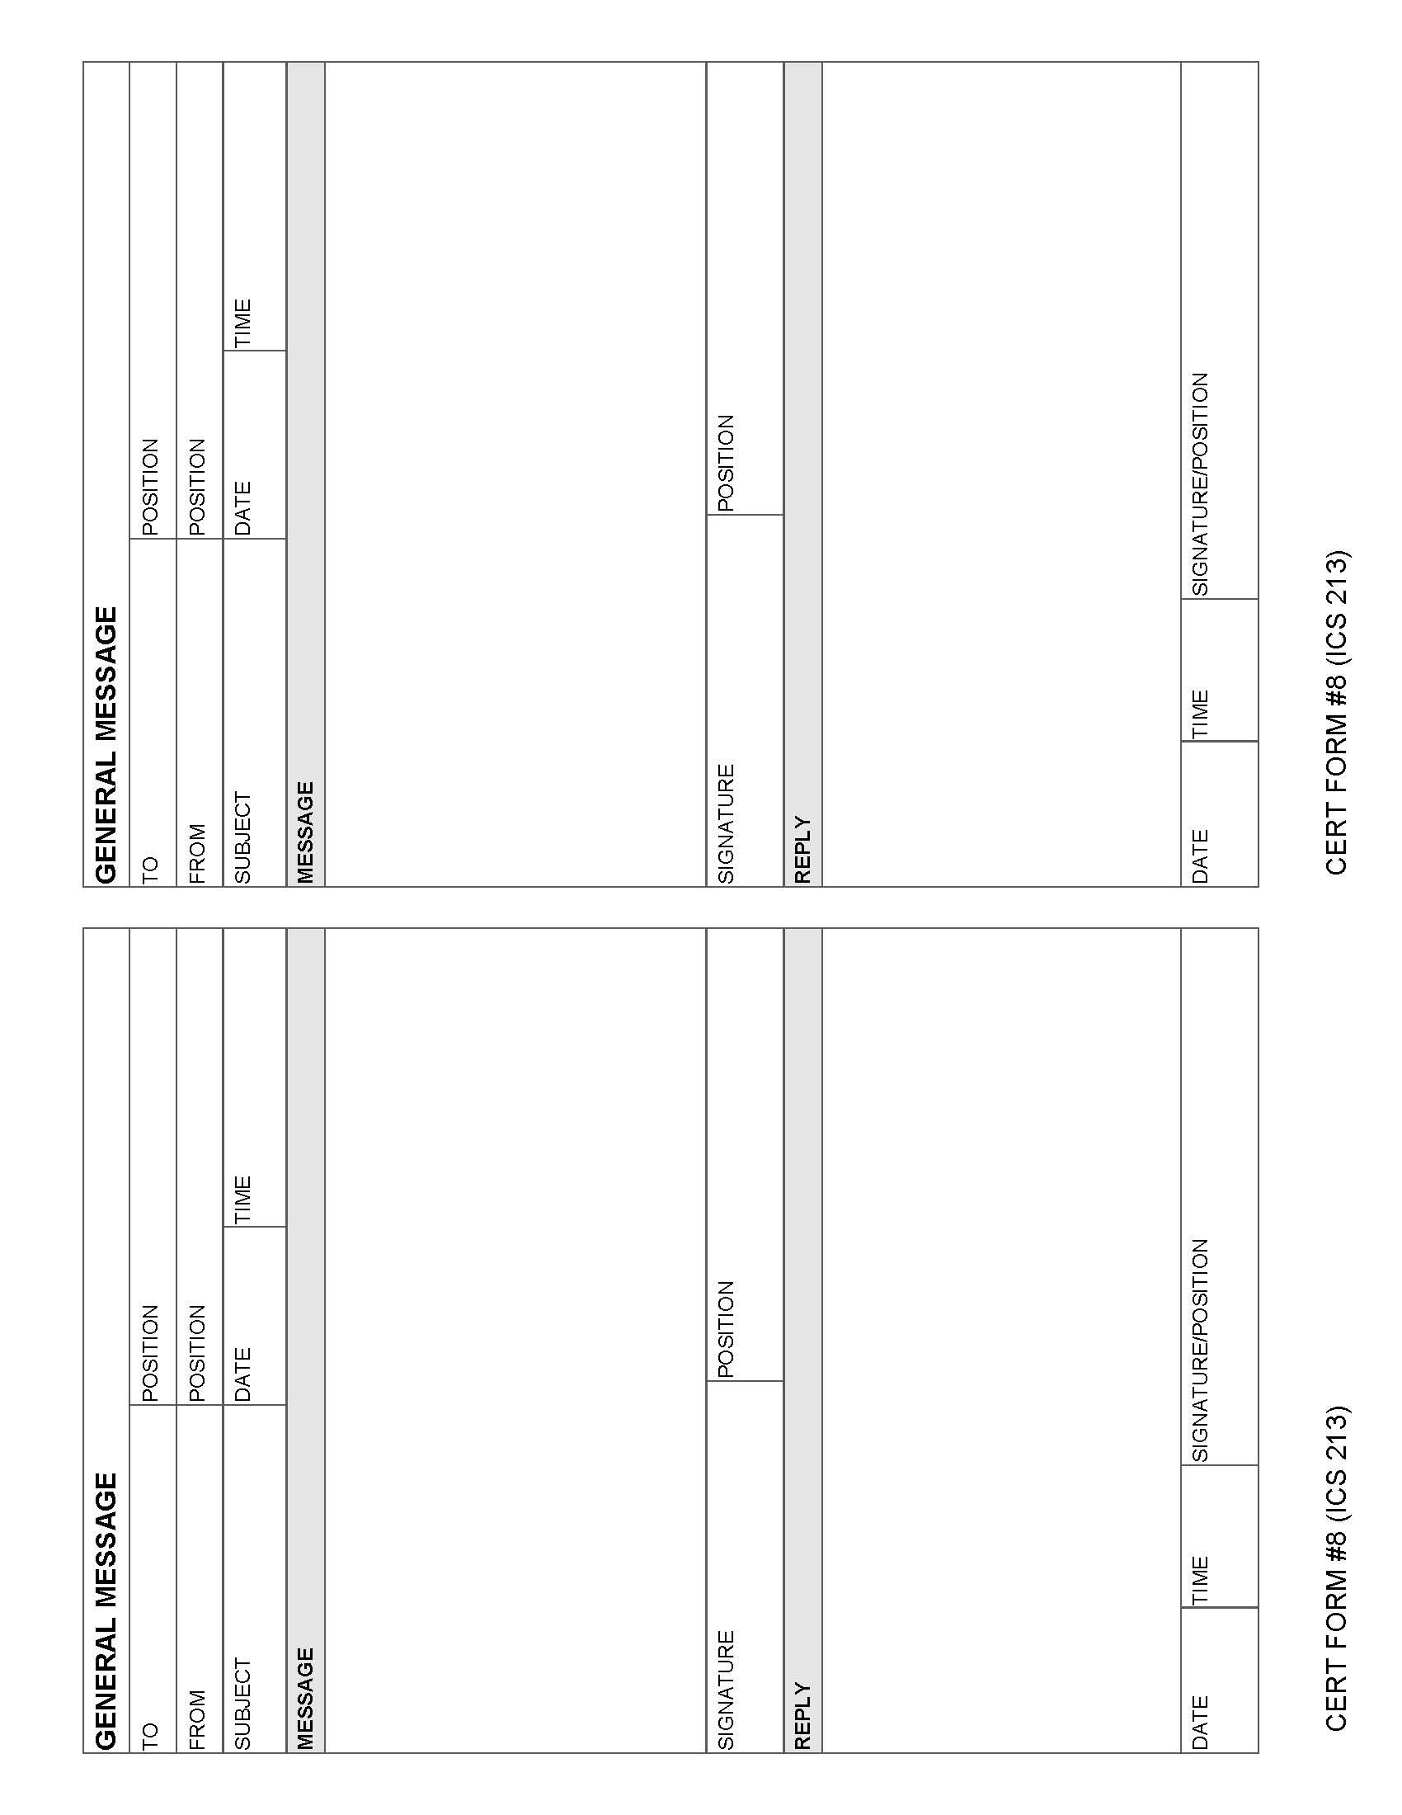
Activity: ICS Functions
Purpose: This activity will give you an opportunity to relate the ICS functions to specific situations.
Instructions:
- Break into small table groups.
- This exercise will provide you with the opportunity to decide under which ICS functions the listed activities will fall.
- Review the list of activities and use the initials, “IC/TL,” “O,” “P,” or “L” to indicate which ICS function would cover each activity.

While Finance/Administration is a part of ICS, it is generally not used by CERTs.

Activity: ICS Functions (Continued)

Instructions:
Using your knowledge about the five ICS functions, decide under which function the following CERT activities would fall. Some activities may involve more than one function to be completed.

Use the following key to fill in the blanks before each activity:
IC/TL = Incident Commander/Team Leader
O = Operations
P = Planning
L = Logistics

- It’s dark, all the lights are out, you need additional flashlights to continue your response.
- The designated first aid site has a downed power line.
- A neighbor reports the smell of gas in his house, but he cannot shut off the gas at the meter.
- The batteries for the portable radio are dead.
- The city wants to know the overall status of your neighborhood.
- Several of your neighbors have minor injuries and need first aid.
- Fire from another neighborhood is moving toward your neighborhood.
- There is a pit bull-type dog seen wandering near the first aid station.
- A news crew has arrived with a camera to film your activities.
- Two hysterical neighbors are demanding help. One cannot find her adolescent child who was playing outside when the disaster struck. The other wants help moving a bookcase off of his wife. He says she’s bleeding from a wound on the head.
- It’s starting to rain. Your command post and the first aid area are not under shelter.
- Too many people are coming to the Incident Commander to ask questions. The IC/TL asks for someone to act as a “gatekeeper.”
- There is a great increase of car and foot traffic through your neighborhood because other roadways are blocked.
- The IC/TL is very tired and is going to hand over responsibilities to someone else. He or she wants a report on the status of the neighborhood before doing so.
- Many neighborhood residents have come to volunteer their help.
- Reports have come in of damage and injuries in the next block. Teams must be assigned to assess the situation.
- A professional responder has arrived at the scene and would like a briefing on situation status.

Activity: Tabletop Exercise
Purpose: This exercise is an interactive tabletop activity that gives you an opportunity to apply what you have learned about ICS for CERT activation.
Instructions:
- Break into small table groups.
- As a group, go through the exercise as if you were in command and in charge of decision-making.
- Remember that CERT command objectives are to:
- Identify the scope of the incident
- Determine an overall CERT strategy
- Set priorities and deploy resources

Unit Summary
The key points from this unit:
- The ICS is the system used by emergency response agencies and CERT to manage emergency operations. ICS provides a flexible means of managing personnel, facilities, equipment, and communication and can be expanded as necessary.
- The key question that CERT Incident Commanders/Team Leaders must always ask is: “Is it safe for CERT members to attempt the rescue?” Whether or not to attempt a rescue depends on the degree of damage to the structure involved. Remember: CERT members’ safety is the number one priority.
- It is vital to document and communicate information about situation and resource status to all CERT levels.
- Sections, Groups, and Teams must provide the Command Post with ongoing information about damage assessment, incident status, and ongoing needs.
- The command post must document the situation status so that the overall disaster situation can be tracked and reported to emergency response agencies.
Homework Assignment
Read and become familiar with the unit that will be covered in the next session.

[This page intentionally left blank]

Unit 6: Additional Materials

[This page intentionally left blank]

DAMAGE ASSESSMENT FORM |  |  |  |  | CERT |  |  |  |  |  |  | DATE
LOCATION
SIZE UP
(check if applicable)
Fires |  | Hazards |  |  |  |  | Structure |  | PEOPLE |  |  |  | Roads |  | ANIMALS
BURNING | OUT | GAS LEAK | H20 LEAK | ELECTRIC |  | CHEMICAL | DAMAGED | COLLAPSED | INJURED | TRAPPED | DEAD |  | ACCESS | NO ACCESS | Injured | trapped | ROAMING
oBSERVATIONS
CERT Member |  |  |  |  |  |  |  |  |  |  |  | page ____ of _____
CERT FORM #1

Personnel resources CHECK-in |  |  | CERT |  |  |  |  |  | DATE
check  in  time | check  OUT  time | name |  | id #  (CERT badge or other) | contact  (cell # or radio) | Prefferred assignment |  |  | SKILLS | team assignment | time assigned
 |  |  |  |  |  | fire | medical | sAr
scribe(s) |  |  |  |  |  |  |  |  | page ____ of _____
CERT FORM #2

ASSIGNMENT TRACKING LOG |  |  | CERT |  |  |  | DATE
assignment |  | assignment |  |  | assignment |  |  | assignment
location |  | location |  |  | location |  |  | location
TEAM |  | TEAM |  |  | TEAM |  |  | TEAM
TEAM LEADER/CONTACT # |  | TEAM LEADER/CONTACT # |  |  | TEAM LEADER/CONTACT # |  |  | TEAM LEADER/CONTACT #
START TIME | END TIME | START TIME |  | END TIME | START TIME | END TIME |  | START TIME | END TIME
1 |  | 1 |  |  | 1 |  |  | 1
2 |  | 2 |  |  | 2 |  |  | 2
3 |  | 3 |  |  | 3 |  |  | 3
4 |  | 4 |  |  | 4 |  |  | 4
5 |  | 5 |  |  | 5 |  |  | 5
OBJECTIVES |  | OBJECTIVES |  |  | OBJECTIVES |  |  | OBJECTIVES
RESULTS |  | RESULTS |  |  | RESULTS |  |  | RESULTS
CERT LEADER/ INCIDENT COMMANDER |  |  |  |  |  |  | PAGE ___ OF ___
SCRIBE(S)
CERT FORM #3

BRIEFING ASSIGNMENT |  |  |  |  | CERT |  |  |  |  |  | Date
COMMAND POST CONTACT # |  |  |  |  |  |  |  |  |  |  | TIME OUT |  |  |  | TIME BACK
INSTRUCTIONS TO TEAM
TEAM NAME |  |  |  |  | LOCATION
OBJECTIVES

EQUIPMENT ALLOCATED

REPORT FROM RESPONSE TEAM
Fires |  | Hazards |  |  |  |  | Structure |  | PEOPLE |  |  |  | Roads |  |  | ANIMALS
BURNING | OUT | GAS LEAK | H20 LEAK | ELECTRIC |  | CHEMICAL | DAMAGED | COLLAPSED | INJURED | TRAPPED |  | DEAD | ACCESS | NO ACCESS |  | Injured | trapped | ROAMING
CERT FORM #4.a
TEAM ACTION LOG
(time stamp each action; draw map if needed)
SCRIBE

CERT FORM #4.b
victim treatment area record |  | CERT |  |  | date
treatment area location
time in | name or description |  | triage tag  (circle) | condition/treatment  (update as needed) |  |  | moved to | time out
Immed
Delay
Minor
Immed
Delay
Minor
Immed
Delay
Minor
scribe(S) |  |  |  |  |  | page ___ of ____
CERT FORM #5

Communications Log |  | CERT |  |  | date
 |  | radio operator name
log
TIME | FROM |  | TO | Message
PAGE_____ OF_____
CERT FORM #6 (Based on ICS 309)

equipment inventory |  | CERT |  |  |  |  |  |  |  | date
asset # | item description |  |  | owner |  | issued to |  | qty | time |  | initials | comments
 |  |  |  |  |  |  | issued
 |  |  |  |  |  |  | returned
 |  |  |  |  |  |  | issued
 |  |  |  |  |  |  | returned
 |  |  |  |  |  |  | issued
 |  |  |  |  |  |  | returned
 |  |  |  |  |  |  | issued
 |  |  |  |  |  |  | returned
 |  |  |  |  |  |  | issued
 |  |  |  |  |  |  | returned
 |  |  |  |  |  |  | issued
 |  |  |  |  |  |  | returned
 |  |  |  |  |  |  | issued
 |  |  |  |  |  |  | returned
 |  |  |  |  |  |  | issued
 |  |  |  |  |  |  | returned
 |  |  |  |  |  |  | issued
 |  |  |  |  |  |  | returned
 |  |  |  |  |  |  | issued
 |  |  |  |  |  |  | returned
 |  |  |  |  |  |  | issued
 |  |  |  |  |  |  | returned
scribe(S) |  |  |  |  |  |  |  |  |  | page ___ of ___
CERT FORM #7 (Based on ICS 303)

GENERAL MESSAGE
TO |  |  | POSITION
FROM |  |  | POSITION
SUBJECT |  |  | DAT |  | TIME
MESSAGE
SIGNATURE |  |  |  | POSITION
REPLY
DATE | TIME | SIGNATURE/POSITION
CERT FORM #8 (ICS 213)
GENERAL MESSAGE
TO |  |  | POSITION
FROM |  |  | POSITION
SUBJECT |  |  | DAT |  | TIME
MESSAGE
SIGNATURE |  |  |  | POSITION
REPLY
DATE | TIME | SIGNATURE/POSITION
CERT FORM #8 (ICS 213)

